An Undergraduate Thesis on

# THESIS TITLE

Course No: NAME 400

By

1st Student’s Name Student ID:

and

2nd Student’s Name Student ID:

Supervised By Professor’s Name Designation

Department of NAME, BUET

Submitted to the

Department of Naval Architecture and Marine Engineering, Bangladesh University of Engineering and Technology,

In partial fulfillment of the requirements For the degree of Bachelor of Science In

Naval Architecture and Marine Engineering



October 2024

Department of Naval Architecture and Marine Engineering, Bangladesh University of Engineering and Technology, Dhaka-1000, Bangladesh[-2mm]

# DECLARATION

This is to certify that the work presented in the thesis is carried out by the authors under the supervision of Dr.Name of the supervisor, Department of Naval Architecture and Marine Engineering, Dhaka. No portion of the work contained in this thesis has been submitted in support of an application for another degree or qualification of this or any other university or institution of learning.

Authors

Name: Student ID: Date:

Name: Student ID: Date:

Supervisor’s Name

Department of Naval Architecture and Marine Engineering Bangladesh University of Engineering and Technology, Dhaka

**DEDICATION**

This thesis is dedicated to .............

**ACKNOWLEDGEMENT**

Input your acknowledgement here.....

**ABSTRACT**

Input your abstract here..... Keywords:

**TABLE OF CONTENTS**

|  |  |
| --- | --- |
| **ACKNOWLEDGEMENT****ABSTRACT**  **NOMENCLATURE AND ABBREVIATIONS** | **iii iv**  **ix** |
| **1 INTRODUCTION** | **1** |
| 1.1 Background and Present State . . . . . . . . . . . . . . . . . . . . . . . . . . | 1 |
| 1.2 Motivation . . . . . . . . . . . . . . . . . . . . . . . . . . . . . . . . . . . . | 2 |
| 1.3 Objective of The Research . . . . . . . . . . . . . . . . . . . . . . . . . . . . | 2 |
| 1.4 Methodology . . . . . . . . . . . . . . . . . . . . . . . . . . . . . . . . . . . | 2 |
| 1.5 Organization of the Thesis . . . . . . . . . . . . . . . . . . . . . . . . . . . . | 2 |
| **2 OVERVIEW** | **3** |
| 2.1 Section 1 . . . . . . . . . . . . . . . . . . . . . . . . . . . . . . . . . . . . . | 3 |
| 2.2 Section 2 . . . . . . . . . . . . . . . . . . . . . . . . . . . . . . . . . . . . . | 3 |
| 2.3 Section 3 . . . . . . . . . . . . . . . . . . . . . . . . . . . . . . . . . . . . . | 3 |
| 2.4 Section 4 . . . . . . . . . . . . . . . . . . . . . . . . . . . . . . . . . . . . . | 3 |
| 2.5 Section 5 . . . . . . . . . . . . . . . . . . . . . . . . . . . . . . . . . . . . . | 4 |
| **3 CHAPTER 3 NAME** | **5** |
| 3.1 Section 1 . . . . . . . . . . . . . . . . . . . . . . . . . . . . . . . . . . . . . | 5 |
| 3.2 Section 2 . . . . . . . . . . . . . . . . . . . . . . . . . . . . . . . . . . . . . | 5 |
| 3.3 Section 3 . . . . . . . . . . . . . . . . . . . . . . . . . . . . . . . . . . . . . | 5 |
| 3.4 Section 4 . . . . . . . . . . . . . . . . . . . . . . . . . . . . . . . . . . . . . | 5 |

3.5 Section 5 5

1. CHAPTER 4 NAME 6
   1. Section 1 6
   2. Section 2 6
   3. Section 3 6
   4. Section 4 6
   5. Section 5 6
2. CHAPTER 5 NAME 7
   1. Section 1 7
      1. sub section 1 7
      2. sub section 2 7
      3. sub section 3 7
   2. Section 2 7
   3. Section 3 7
   4. Section 4 8
   5. Section 5 8
3. RESULTS AND DISCUSSIONS 9
4. CONCLUSIONS AND FUTURE SCOPES 10

BIBLIOGRAPHY 11

APPENDIX 12

**LIST OF FIGURES**

* 1. *𝐶𝑑* vs Re 1
  2. Flow around a circular cylinder 2
  3. (a) *𝐶𝑑* vs Re and (b) Streamline Plot 3
  4. *𝐶𝑑* vs Re 4
  5. Streamline Plot 4

**LIST OF TABLES**

* 1. Drag coefficients at different Reynolds numbers 2

**NOMENCLATURE AND ABBREVIATIONS**

*𝐶𝑑* Drag Coefficient

*𝐶𝑙* Lift Coefficient

*𝑅𝑒* Reynolds Number

**Chapter 1**

# INTRODUCTION

### Background and Present State

Insert text here. For example, this refers to a paper Ali and Bogna´r (2024). Two or more papers can be cited as (Ali and Bogna´r, 2024; Mohammadpour et al., 2024). You can insert an equation. One example is

*𝐶𝑑* =

2*𝐹𝑑* (1.1)

*𝜌𝑈*2 *𝐴*

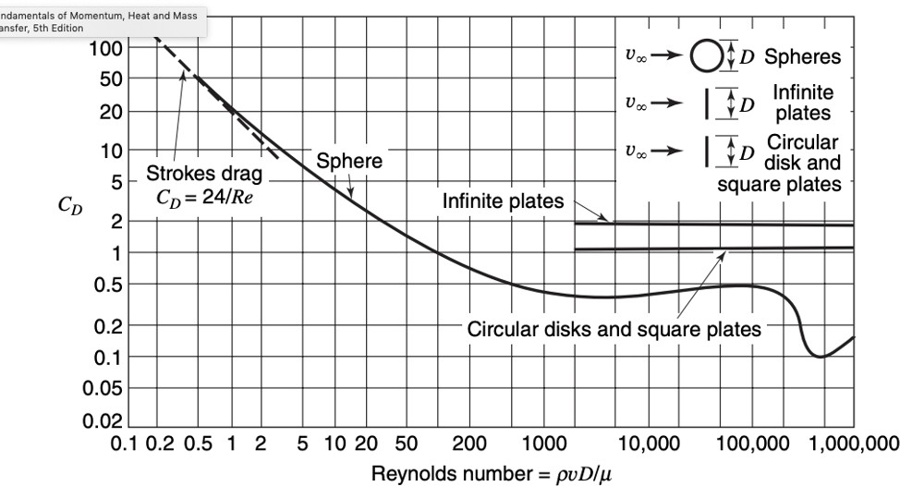

Figure 1.1: *𝐶𝑑* vs Re

### Motivation

The drag coefficient *𝐶𝑑* and Reynolds number *𝑅𝑒* are essential in fluid dynamics.

### Objective of The Research

Insert Text Here.

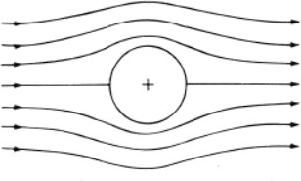

Figure 1.2: Flow around a circular cylinder

### Methodology

Insert Text Here

|  |  |
| --- | --- |
| Re | *𝐶𝑑* |
| *𝑅𝑒*1 | *𝐶𝑑*1 |
| *𝑅𝑒*2 | *𝐶𝑑*2 |

Table 1.1: Drag coefficients at different Reynolds numbers

### Organization of the Thesis

Insert Text Here

## Chapter 2 OVERVIEW

### Section 1

Insert Text Here. The number and name of the sections can vary according to your thesis. Let’s add two figures side by side.



(a) (b)

Figure 2.1: (a) *𝐶𝑑* vs Re and (b) Streamline Plot

### Section 2

Insert Text Here

### Section 3

Insert Text Here

### Section 4

Insert Text Here. Let’s use two figures with different numbers side by side.

 

Figure 2.2: *𝐶𝑑* vs Re Figure 2.3: Streamline Plot

0

### Section 5

Insert Text Here

**Chapter 3**

# CHAPTER 3 NAME

### Section 1

Insert Text Here. The number and name of the sections can vary according to your thesis.

### Section 2

Insert Text Here

### Section 3

Insert Text Here

### Section 4

Insert Text Here

### Section 5

Insert Text Here

**Chapter 4**

# CHAPTER 4 NAME

### Section 1

Insert Text Here. The number and name of the sections can vary according to your thesis.

### Section 2

Insert Text Here

### Section 3

Insert Text Here

### Section 4

Insert Text Here

### Section 5

Insert Text Here

**Chapter 5**

# CHAPTER 5 NAME

### Section 1

Insert Text Here. The number and name of the sections can vary according to your thesis.

### Sub section 1

Insert Text Here

### Sub section 2

Insert Text Here

### Sub section 3

Insert Text Here

### Section 2

Insert Text Here

### Section 3

Insert Text Here

### Section 4

Insert Text Here

### Section 5

Insert Text Here

**Chapter 6**

# RESULTS AND DISCUSSIONS

**Chapter 7**

**CONCLUSIONS AND FUTURE SCOPES**

**Bibliography**

Zainab Ali and Gabriella Bogna´r. Rans study of surface roughness effects on ship resistance.

*Journal of Nonlinear, Complex and Data Science*, (0), 2024.

Javad Mohammadpour, Fatemeh Salehi, Vikram Garaniya, Til Baalisampang, Ehsan Arzaghi, Ross Roberts, Gio Cervella, Jason Newport, Peter Hughes, and Rouzbeh Abbassi. Compu- tational analysis of air bubble-induced frictional drag reduction on ship hulls. *Journal of Marine Science and Technology*, pages 1–15, 2024.

**APPENDIX**