TITE of the paper {TREBUCHET MS FONT, SIZE 16, BOLDED, CENTRED, CAPITALIZED}

First Author's First Name Initial. First Author's Middle Name Initial. First Author's Last Name Full¹, Second Author's First Name Initial. Second Author's Middle Name Initial. Second Author's Last Name Full² and Third Author's First Name Initial. Third Author's Middle Name Initial. Third Author's Last Name Full³ { Times New Roman Font, Size 12, Centered, Bolded}
¹First Author's Department, Instituion, Address, Email address {Times New Roman Font, Size 9, Left Justified, single spaced}
²Second Author's Department, Instituion, Address, Email address
²Second Author's Department, Instituion, Address, Email address

Abstract: {Times New Roman Font, Size 10, Bolded, Italic, Left justified}
This document describes how the finally submitted accepted paper will be formatted. Title of the paper should be according to the format given in curly bracket {}. Author’s name should be according to the format given in curly bracket {}. Abstract will be written according to the format given in the curly bracket {}. Abstract content is written with Times New Roman font, size 9, full justified, single spaced. This part should describe the summary of the work to be presented in the technical paper, especially results and findings of the work. Please do not include any mathematical expression, graphs, figures, tables nor references in the abstract text. The abstract content should be composed out of maximum 200 words, contained in one paragraph only, the paragraph is indented 0.6 cm from left and 0.5 cm from right margin.

Keywords: Minimum four keywords should be given, times new roman font, size 10, align left.

NOMENCLATURE |  | Greek symbols
 | velocity components | β | coefficient of thermal expansion
u, v | dimensionless velocity components | ν | kinematic viscosity

1. Introduction {Times New Roman font, size 12, left justified, bold, capitalized each word}

Paper contents are written with Times New Roman font, size 10, full justified, single spaced. The contents should comprise of the following sections: Introduction, Mathematical Formulation/Experimental Methods, Results and Discussion, and Conclusion. The first sentence in each paragraph will not have any indentation. The heading will be written in Times New Roman font, size 12, bold and left justified with each word capitalized. The sub-heading will be written in Times New Roman font, size 12, bolded and left justified with sentence case. Mathematical notations and equations are written with Times New Roman font, size 11, should be numbered accordingly, adequately spaced from the main text as shown in Eq. (1) and Eq. (2). Each variable in the equation should be clearly defined and alphabetical & Greek symbols should be explained under NOMENCLATURE.

(1)
(2)

Abbreviation(s) (if any) should be defined the first time it appears in the text; for instance, International Maritime Organization (IMO); and then the abbreviation only should be used after wards.

1.1 Table format {Sub-heading: Times New Roman font, size 12, left justified, Sentence case}

Tables should be kept simple and clear, and should be referred to in the text. They should be centered, numbered, titled (above the table), and typed using single spacing and positioned as close to the place where those are referred.

1.1.1 Contents of table {Sub-sub-heading: Times New Roman font, size 10, left justified, italic, sentence case}

Content of table is written with Times New Roman font, maximum size 10. Example of table presentation is shown in Table 1.

Table 1: Parametric details of numerical models used to study the analysis
Parameters | Magnitude
Length, L | 1000m
Breadth, B | 100m
Draft, d | 5m
Youngs modulus, E | 5.789
Structural density, ρ_{s} | 8.5690
Density of water, ρ_{w} | 1025
Water depth, h | 20m
Wavelength, λ | 3m

1.2 Illustrations

Illustrations, including diagrams, graphs, and photographs should be provided in a clear format and referred to in the text. They should be centered, numbered, titled (underneath the illustration), using single spacing and positioned as close to the place where those are referred.

Example of presenting illustration is as shown in Fig. 1. The space occupied by a figure should not exceed one quarter of a page.
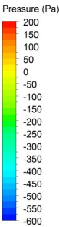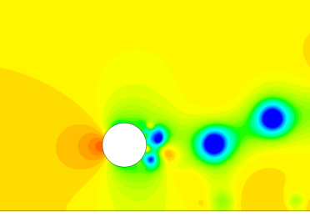 | 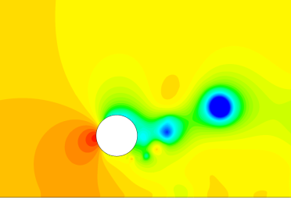
Fig. 1: Pressure fields around the cylinder at G/D = 1.0 with LES | Fig. 2: Pressure fields around the cylinder at G/D = 1.0 with SST.
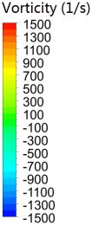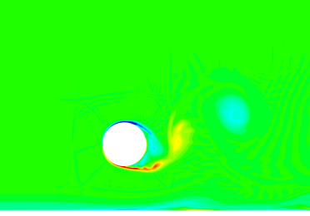 | 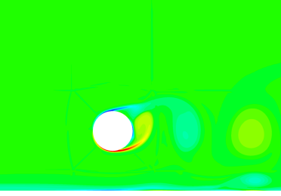
Fig. 3: Vorticity around the cylinder at G/D = 1.0 with LES. | Fig. 4: Flow fields around the cylinder at G/D = 1.0: with SST.
2. Conclusions

This section makes general comments based on results and discussion.

3. Acknowledgements {Title, Times New Roman font, size 12, bolded and left justified}
Acknowledgements conveyed to person(s) or institution(s) related to the work contained in the paper may be included at the end of the manuscripts, before the list of references, composed of not more than 50 words, written in Times New Roman font, size 10 as shown below:

4. References {Title, Times New Roman font, size 12, bolded and left justified}
Reference should be listed alphabetically (without numbering) at the end of the paper as shown below. They should be cross-referenced in the text by using the author's last name and publication year in the style of Black (1995), Daidola and Johnson (1992) or (Coney, 1989) according to context. More than two authors can be abbreviated to Eyi et al (1994). DOI number should be cited if available. Please visit CrossRef to retrieve Digital Object Identifiers (DOIs) for journal articles, books, and chapters. Do not abreviate journal name, i.e., write full name of journal. Capitalize each word of 'Title' except article, preposition, consonant etc. which are not used as first word.

Acknowledgements

The authors gratefully acknowledge the financial support provided by {Name of sponsor}.

References

Black, S. D. (1995): The use of numerical optimization in advanced blade section design, Proceedings of 24th ATTC, Texas, A&M University, USA.
Coney, W. B. (1989): A method for the design of a class of optimum marine propulsors, PhD thesis, Department of Ocean Engineering, MIT, USA.
Daidola, J. C. and Jhonson, F. M. (1992): Propeller selection and optimization program (PSOP), Technical and Research Bulletin No. 7-6, SNAME, USA.
Eyi, S., Hager, J. O. and Lee, K. D.(1994): Airfoil design optimization using the Navier-Stokes equation, Journal of Optimization Theory and Applications, Vol. 83, No. 3, pp. 447-46.
http://dx.doi.org/10.1007/BF02207637
Van Dyke, M. (1975): Perturbation methods in fluid mechanics, The Parabolic Press, Stanford, California.
Tachmindji, A. J. and Milan, A. B. (1956): The calculation of Goldstein factors for three, four, five, and six bladed propellers, Technical Report 1051, DTMB, USA.

